Robotic Solar Farm Grass Cutting System Design Challenge
Sponsor: Orlando Utility Commission, Duke Energy

Group 23

Joseph Morelli | EE - Comprehensive

Daniel Corbellini | EE - Power and Renewable Energy

Tyler Bradley | EE - Comprehensive

Nathaniel McKain | CpE - Comprehensive
Project Narrative

Solar farms utilize photovoltaic panels to convert sunlight into electrical energy. The solar panels are ground-mounted and require maintaining grass and weeds that grow around the base. Conventional mowing techniques can be challenging to implement due to these dense and difficult to reach areas. While there are various ways to approach this, this project aims to minimize the monthly expenses of ground maintenance by using AI-assisted, autonomous solar powered rover-based robots to articulate and guide electric weed whackers.

This is the next phase of the competition from the original phase 1 that occurred during the 2018-2019 school year. Phase 2 is to focus on the navigation and mobility aspects of the device. The main objective is to complete the 10-foot-wide, by 50-foot-long course working around the obstacles within a 15-minute time constraint. The optimal design will integrate the best technology at the lowest cost. Considerations for Safety, reliability, and durability are an absolute requirement.

Requirement Specifications
Table 1:Requirement Specifications
No. | Requirement Specifications
1 | Cost | The design should be as low of a cost as possible without reducing the overall functionality
2 | Navigation | Should identify areas that need attention and to avoid all obstacles in the way
3 | Power Supply | Should output enough power for the mower to be operable for at least one hour, and rechargeable so that it can store energy throughout the night if needed.
4 | Motion | Need to be able to move the mower across the field to cut the grass
5 | Control system | Determine what signal needs to travel where to determine what motor needs to run to travel to destination

Each system and device/component will be considered for its practicality, reliability, durability, safety, cost, efficiency, and simplicity.
Block Diagrams
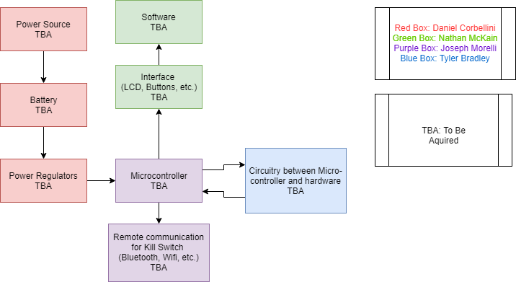
Figure 1: Block diagram
Project Budget

Doing an interdisciplinary project means we will have greater budget than the average group. Our total system materials and assembly cost target is $1500. We are looking at spending $500 – $700 on parts depending on the quality of parts, where we buy them, and what features we really want. The main components we will be needing for the eGOAT are Wheels, Bearings, a Motor, Battery, LiDAR, camera, boards, and some other computer hardware. Our team will break down what we want and need with the other engineering groups once we all meet and come together. Our parts will be split amongst the groups in such a way that what we are buying pertains more to their respective specialization. We will also discuss our project budget more with our sponsors to ensure we are building this project within our means and budget incase our budget goes higher or lower. The break down for some possible example parts and our minimum parameters for that part are as follows.

Table 2: Budget
Discipline | Component | Minimum Parameters | Example Part | Cost
Mechanical | Wheels | Drive Wheels: Drive Wheels: rubber, deep treads. Follower wheels: rubber or polyurethane, outdoor designated materials only | Robot Drive Wheel - Traction Lug 10 x 3.5-4 Tiller Tire | $18.90
Mechanical | Bearings | Stainless Steel, double sealed/outdoor use designated | XiKe 4 Pack Flanged Ball Bearings | $14.99
Mechanical | Motor | 12V DC, 75 in-oz | Lynxmotion 12V 90rpm 99.11 in-oz 1:26.9 Brushed DC Gear Motor w/ encoder | $70.40
Mechanical | Motor | 12V DC, 75 in-oz | 12V 80rpm 47.77 oz-in 1:26.9 Brushed DC Gear Motor w/Encoder | $65.60
Electrical | Battery | Ah rating allowing for 1 hour of runtime | NiMH Battery Pack: 12V 10Ah (120 Wh 2x5D) for Portable Devices (Combo Option: RB-HD10R2T-MT) | $107.95
Electrical | Battery | Ah rating allowing for 1 hour of runtime | Duracell Ultra 12V 5Ah AGM SLA Battery | $32.99
Electrical | Battery | Ah rating allowing for 1 hour of runtime | Energup 5000mAh Ryobi 18V Lithium Battery Replacement for Ryobi 19-Volt ONE+ | $32.99
Electrical | LiDar | 10m range | YDLIDAR X4 - 360def 10m 2d LIDar | $109.00
Electrical | Camera | 720p quality | Logitech C270 | $39.99
Comp Sci. | Boards | 2 GB RAM for primary boards (4 GB RAM recommended), Ethernet or Serial communications for all boards | Raspberry Pi 4 Model B - $55.00 | $55.00
Comp Sci. | Boards |  | Odroid-XU4 Single Board Computer with Quad Core 2GHz A15, 2GB RAM, USB 3.0 | $84.51
Comp Sci. | Boards |  | Raspberry Pi Zero v1.3 | $5.00
Comp Sci. | Computer Hardware | Min 50 foot range | Intel NCSM2450.DK1 Movidius Neural Compute Stick | $79.00
Comp Sci. | Computer Hardware | Min 50 foot range | Adafruit RFM96W 433MHz LoRa Radio Transceiver | $19.95

As seen from the table there are many possible ways to go when it comes to parts. They can become very expensive very quickly. The most notable part with a fluctuating price looks to be the battery. The battery could be $107.95 or it could go as low as $32.99, it is important for our group to take parts like this into consideration and think about what the more expensive one can do, or what does it offer that the cheaper one does or does not. We want good quality materials that will get the job done but we also want to ensure we aren’t wasting money. When buying our parts we will always consider our minimum parameters first and foremost, then see what we have left from our budget to spend.

Figure 3: House of Quality
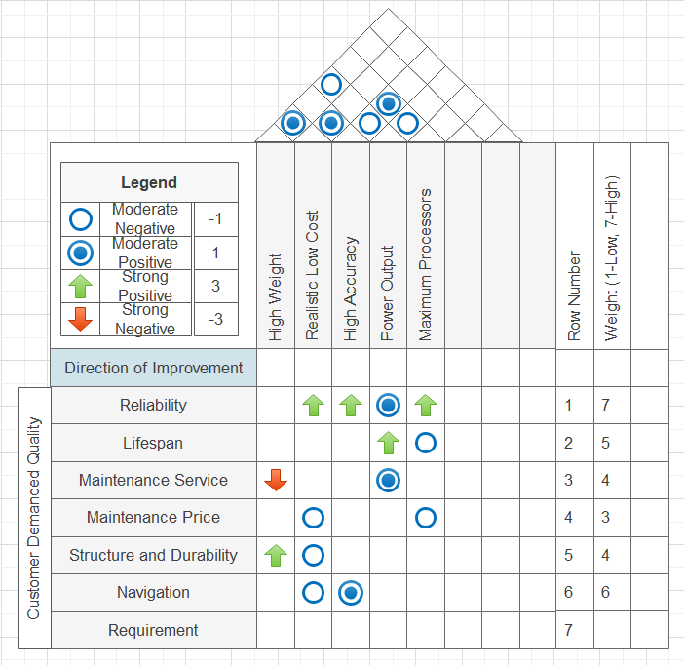

Milestones

Semester 1

- Research techniques for developing optimal energy accumulation and storage through solar panels, programming an autonomous navigation robot that steers through information from sensors, and programming a mechanical robotic arm to control an electric weed whacker.
- Select and study microcontroller and CPU processor to control circuitry.
- Begin circuit design for separate systems of.
- Begin coding machine software alongside hardware design to efficiently work through entire system processes.
- Complete design of individual systems.
- Implement systems together as one process.
- Create a user interface to control robot.

Semester 2

- Research circuit components to choose optimal parts for project.
- Find materials suitable for durability, reliability, safety, and efficiency.
- Order PCB and carry out construction of project.
- Debug and change what’s necessary for operation of product.
- Win 1st place in Senior Design competition.

